# Unit 5 - Assignment

This assignment will test your knowledge of the following areas:

* Creating Windows Form Application Project
* Designing Forms
* Working with controls
* Event-driven programming

## Introduction

This phase of the project will have you begin development on the Windows application. This application will require you to use parts of the class library you developed in previous phases of this project.

## Requirements

### Visual Studio Solution

Create a new Visual Studio Solution named RRCAGWindowsFirstLast, where First and Last correspond to your first and last names.

Create the solution with a Windows Form Application project name the project RRCAGApp.

### API

Your new project will need a reference to your API developed in previous assignments.

### Form Design Images

The Window’s theme used for your operating system may differ from the theme used in design screenshots. You are not required to match the theme used in the screenshot.

### Launcher Form

The launcher form is used to launch other forms within the application.

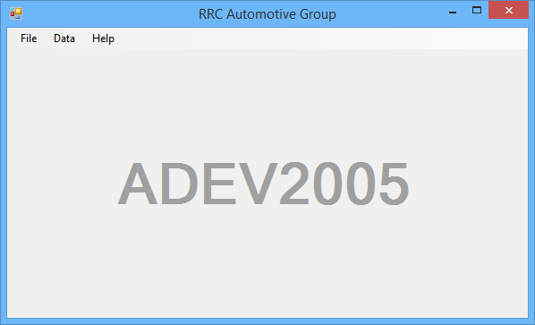

#### **Initial State**

* Menu Strip docked to the top of the Form.
* “ADEV2005” Label docked to the center of the Form.
  + Font: Microsoft Sans Serif, 48pt, Bold, Foreground Colour: ButtonShadow,
  + Text: “ADEV2005” alignment is centered (horizontally and vertically). Note: The alignment of the text will stay consistent, even when the form is resized.
* Title of the form set to “RRC Automotive Group”
* When the form is shown its window state is maximized.

#### **Menu Strip Design and Functionality**

* File
  + Open
    - Sales Quote… (Ctrl+1)
    - Car Wash… (Ctrl+2)
  + [Separator Line]
  + Exit (Alt+F4)
* Data
  + Vehicle… (Ctrl+Shift+V)
* Help
  + About…

**Note**: The menu strip items must be named correctly, include keyboard accessors and keyboard shortcuts as outlined (in parentheses) above.

##### **Sales Quote Menu Item**

When the sales quote menu item is clicked an instance of the sales quote form is shown as a modal window.

##### **Car Wash Menu Item**

This menu item will be used in a future assignment.

##### **Exit Menu Item**

When the exit menu item is clicked, the launcher form closes (ending the application).

##### **Vehicle Menu Item**

This menu item will be used in a future assignment.

##### **About Menu Item**

When the about menu item is clicked an instance of the about form is shown as a modal window.

### About Form

The about form is used to display information about the application.

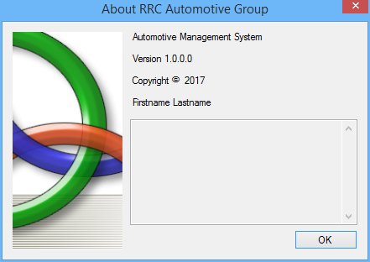

Substitute “Firstname Lastname” with your first and last name.

### Sales Quote Form

Design the sales quote form to match the following design:

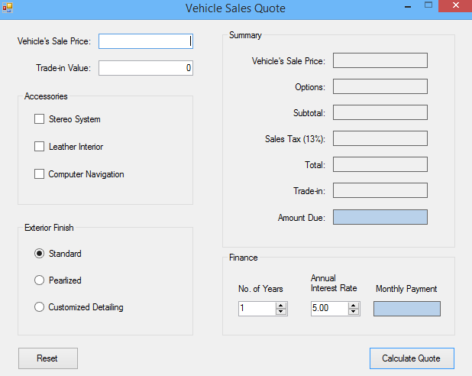

**Note**: The border of the form was omitted from the above screenshot.

#### **Form Initial State**

The form will have the following initial state:

* The title of the form is “Vehicle Sales Quote”.
* The form cannot be maximized.
* The form (window) cannot be resized by the user.
* The vehicle sales price Textbox has no input (blank) and has focus.
* The trade in value Textbox is input is set to 0 (zero).
* No accessories are chosen.
* Standard exterior finish is chosen.
* The summary output labels are blank and the text is middle-right aligned.
* The Sales Tax Label shows the current sales tax rate.
* The number of financing years is set to 1.
* The annual interest rate is set to 5%.
* The monthly payment label is blank and the text is middle-center aligned.
* Error icons are not visible.
* The calculate quote button is the accept button.

#### **Tab Order**

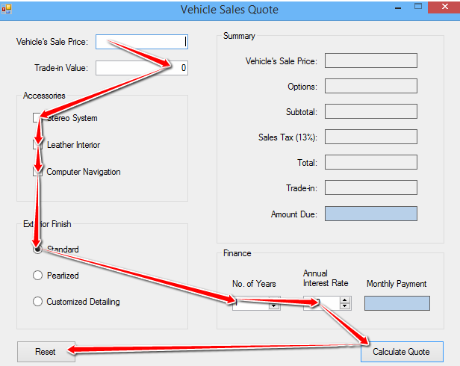

#### **Number of Years Input**

The number of years input will be configured as follows:

* Minimum value: 1
* Maximum value: 10
* Increment: 1

#### **Annual Interest Rate Input**

The annual interest rate input will be configured as follows:

* Minimum value: 0
* Maximum value: 25
* Two decimal places
* Increment: .25

#### **Amount Due and Monthly Payment Output**

The background color of these labels are GradientActiveCaption.

#### **Input Validation**

Inputs are validated when the Calculate Quote button is clicked. When an input is invalid an error icon will be displayed to the right of the control with a padding of 3. The icon will not blink and will display the following error messages.

#### **Vehicle Sale Price**

Error message when there is no input: Vehicle price is a required field.

Error message when the input is not numeric: Vehicle price cannot contain letters or special characters.

Error message when the input is less than or equal to zero: Vehicle price cannot be less than or equal to 0.

#### **Trade-in Value**

Error message when there is no input: Trade-in value is a required field.

Error message when the input is not numeric: Trade-in value cannot contain letters or special characters.

Error message when the input is less than zero: Trade-in value cannot be less than 0.

Error message when the input is greater than the vehicle sale price (Note: this validation should only happen when the vehicle sale price is validated): Trade-in value cannot exceed the vehicle sale price.

#### **Invalid Input**

When either of the inputs is invalid, the summary section output labels will be blank along with the monthly payment.

#### **Calculating Vehicle Sales Quote**

When all inputs are valid, a new sales quote will be created. The sales quote data will be displayed to the summary and finance output controls.

The summary and finance output will be formatted as:

* Vehicle Sale Price (Currency)
* Options (Number)
* Subtotal (Currency)
* Sales Tax Amount (Number)
* Total (Currency)
* Trade-in: (Negative Number)
* Amount Due: (Currency)
* Monthly Payment (Currency)

**Note**: Options output displays the cost of the Accessories and Exterior Finish chosen.

#### **Textboxes**

When the text within the vehicle sales price or trade-in value changes, the following must occur:

* Clear the output labels in the Summary section of the form.
* Clear the monthly payment label in the Finance section of the form.

#### **Accessories and Exterior Finish**

When an accessory or exterior finish is selected and a sales quote has been created, the summary and monthly payment output will be updated to reflect the input change. If a sales quote has not been created, no UI update is made.

#### **Number of Years and Annual Interest Rate**

When the number of years or annual interest rate is changed and a sales quote has been created, the monthly payment output will be updated to reflect the new input value. If a sales quote has not been created, no UI update is made.

#### **Form Reset**

When the Reset button is clicked, a dialog box is displayed to the user to confirm the action. The dialog box will display as:

* Text: Do you want to reset the form?
* Caption: Reset Form
* Buttons: Yes/No
* Icon: Warning
* Default Button: No

If the Yes button is clicked, the form and its controls will be reset back to their initial states (see Form Design and Initial State above).

## Testing

Ensure the application is fully tested before user acceptance testing (UAT). Developing a list of test cases prior to testing will help eliminate missing tests.

Unit testing is not required, but is something you can do with form classes.